Bath Archer at the Archery GB talent league festival.

In August, Jade Pocock (age 14) was invited to compete in the week long talent league festival, held at Lilleshall National Sports Centre. This consisted in a 720 round qualifier, then head to heads, Jade qualified 5th, won 12 out of 14 head to heads and reached the quarter finals. The festival also included a team event, and Jades team won their group. Then straight after this competition Jade stayed at Lilleshall to compete in the Academies cup, the Academies cup is the end of a yearlong program where talented archers are chosen by Archery GB to have performance training by the country’s top coaches, where she represented the Southern region, against other academies from the Midlands and the North, Scotland and Wales. Jade finished again in the quarter finals, after taking her match to a 5 set draw, and finished third in the mixed team event.

Jade has now been chosen to stay at the Southern Academy for another year to carry on her performance training with Archery GB.

Three Bath Archers juniors also represented the county of Somerset at an Intercounties competition, shooting age related Metric rounds, the team was made up of Archers from all over the county, so to get 3 of our local girls in the team for the second year running is some achievement, they are Jade Pocock, Bethany Ede and Molly Stone. They all shot brilliantly on the day with Bethany claiming her Junior Master Bowmen award. Somerset finished a very close 4th position, Jade winning her age group and Bethany second in hers.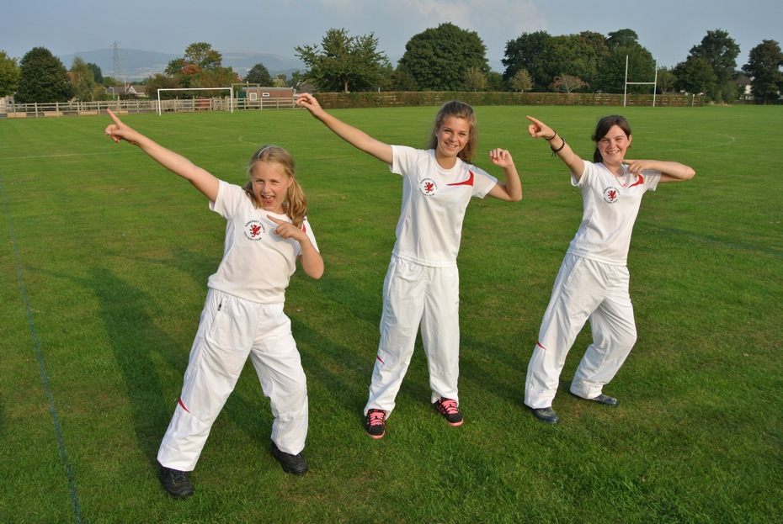

The Somerset Interclubs were also held this weekend at Gordano archers, everyone shot western rounds at age related distances, unfortunately Bath didn't make a team due to lack of entrants but those that did go shot amazingly, the "team" that represented Bath were Colin Deacon, gents recurve, Kay Deacon, winning the ladies longbow and Jade Pocock, winning the under 16 category and highest scoring under 18.